**Name of the project**

**Project plan**

Team name: PMJ

Team members: Pontus Olsson Martin Eriksson Jonas Karlsson

Date: 2015-04-27

**Contents**

1 Introduction​ and background 3

2 Aim and purpose 3

2.1 Research questions 3

2.2 Limitation 3

3 Method 3

3.1 Literature review 3

3.2 Benchmarking 4

4 Expected Results 4

5 Social and ethical aspects 4

6 References 4

7 Appendix and enclosures 5

# Introduction​ and background

This project was chosen because it is an interesting area of expertise. It is also a subject that is scientific interesting in this technical era, and that shall be mastered in the coming years. Background knowledge for this project has been articles, lectures in software engineering and lectures in programming courses.

# Aim and purpose

We aim to produce a product that will record a voice command and compare it to a database and based on what command was sent, different lights should be turned on.

## Research questions

Is voice recognition reliable when used as an input command?

Can voice recognition be used to improve quality of life for the disabled?

Will atmega328p have the computing power to fully operate with voice recognition?

## Limitation

This project will be a small one because there is not much time and the software is new to us.

Budget and knowledge is also two big limitations.

# Method

## Literature review

According to the literature voice recognition is not a reliable source when it comes to input commands, it is not developed enough to be considered a reliable input program.

In the article which sought to answer our third research question (Nanda & Dhande, 2012), we did not quite get the answer we wanted. As the research conducted in this article was performed with a different microprocessor optimized for speech recognition it’s kind of diffuse if the ATmega328p processor can handle it. To either find this answer with others research or by finding out ourselves is less important.

In (Zhong, et al., 2014) they talk about how voice controlled systems can help blind or disabled people when it comes to doing something simple like calling someone or even search for something on Google.

We searched for articles that had a connection with our topic.

We have considered a lot of different articles but we decided the ones we have are to most correct and fitting for our project.

We discarded a lot of articles because they were not fitting for our project and/or they were not good enough.

The conclusion from the articles is that this project is very interesting and should be worked on a lot more and developed further to increase the potential of voice control. Considering this technological age, voice recognition should be a standard in some things.

## Benchmarking

The product that will be complete after this project is not a complete product, it only scratches the top of something huge! This project is kind of a start to a bigger project that could be used and be integrated in a lot of places.

# Expected Results

We expect to deliver a finished product that should be able to turn on and off lights depending on the voice command given.

# Social and ethical aspects

It might be discriminating to some people with broad dialects and accents.

# References

Nanda, S. K. & Dhande, A. P., 2012. Microcontroller Implementation of a Voice Command Recognition System for Human Machine Interface in Embedded System. 1(1), p. 4.

Saume, D. L. &. C., 2012. En undersökning av röststyrning för Android-enheter. Volym 1, p. 35.

Zhong, Y. o.a., 2014. JustSpeak: Enabling Universal Voice Control on Android. p. 4.

# Appendix and enclosures

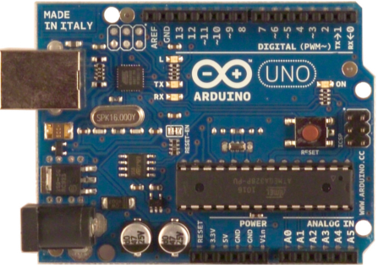

Figure 1. Atmega328p (microprocessor)